**Student Result Management System**

**Mini Project - 2**

**SYNOPSIS**



Department of Computer Science Engineering & Applications

**Institute of Engineering & Technology**

## Submitted to: - Submitted by: -

Mr. Manoj Varshney Ayush Singh (191500202)

(Assistant Professor)

Page 1 of 12

## ACKNOWLEDGEMENT

It gives me a great sense of pleasure to present the synopsis of the B.Tech Mini Project Student Result Management System undertaken during B.Tech IIIrd Year. This project in itself is going to be an acknowledgement to the inspiration, drive and technical assistance will be contributed to it by many individuals.

I owe Special debt of gratitude to **Mr. Manoj Varshney** , Assistant Professor Department of **CEA** , for providing me with an encouraging platform to develop this project , which thus helped us in shaping our abilities towards a constructive goal and for his constant support and guidance to our work.

His sincerity, thoroughness and perseverance has been a constant source of inspiration for me. I believe that he will shower us with all his extensively experienced ideas and insightful comments at different stages of the project & also taught me about the latest industry-oriented technologies.

I also do not like to miss the opportunity to acknowledge the contribution of all faculty members of the department for their kind guidance and co-operation.

**Ayush Singh (191500202)**

Page 2 of 12

## Contents

Declaration ---------------------------------------------------(1)

Acknowledgement-------------------------------------------(2)

Introduction---------------------------------------------------(4)

Objective------------------------------------------------------(5)

Requirement Analysis

* Hardware Requirement-----------------------------(6)
* Software Requirement------------------------------(6)

Technology Used--------------------------------------------(7)

Picturization Of Our Model--------------------------------(8)

Future Scope------------------------------------------------(11)

References---------------------------------------------------(12)

Page 3 of 12

# Introduction

The "Student Result Management System" has been developed to override the problems prevailing in the practicing manual system. This software is supported to eliminate and in some cases reduce the hardships faced by this existing system. Moreover, this system is designed for the particular need of the company to carry out operations in a smooth and effective manner.

The application is reduced as much as possible to avoid errors while entering the data. It also provides error message while entering invalid data. No formal knowledge is needed for the user to use this system. Thus by this all it proves it is user-friendly. Student Result Management System, as described above, can lead to error free, secure, reliable and fast management system. Thus it will help organization in better utilization of resources.

Every organization, whether big or small, has challenges to overcome and managing the information’s of Student, Result, Activity, Course, Exam. Every Student Result Management System has different Result needs; therefore, we design exclusive employee management systems that are adapted to your managerial requirements. This is designed to assist in strategic planning, and will help you ensure that your organization is equipped with the right level of information and details for your future goals. Also, for those busy executive who are always on the go, our systems come with remote access features, which will allow you to manage your workforce anytime, at all times. These systems will ultimately allow you to better manage resources.

Page 4 of 12

## Objective

The main objective of the Project on Result Management System is to manage the details of Result, Student, Progress, Activity, Exam. It manages all the information about Result, Course, Exam, Result. The project is totally built at administrative end and thus only the administrator is guaranteed the access. The purpose of the project is to build an application program to reduce the manual work for managing the Result, Student, Course, Progress. It tracks all the details about the Progress, Activity, Exam.

## Functionalities provided by Result Management System are as follows:

* Provides the searching facilities based on various factors. Such as Result, Progress, Activity, Exam
* Result Management System also manage the Course details online for Activity details, Exam details, Result.
* It tracks all the information of Student, Course, Activity etc
* Manage the information of Student
* Shows the information and description of the Result, Progress
* To increase efficiency of managing the Result, Student

Page 5 of 12

# REQUIREMENT ANALYSIS

## Hardware Requirement :-

Hard Disk : 100 MB upto 500 MB

RAM : 1 GB

Processor : 1.6 GHz or faster processor

## Software Requirements :-

Operating System : Windows, Linux, MAC OS

User Interface : HTML , CSS , JAVASCRIPT,BOOTSTRAP

Database : MySQL

Programming Language : PHP

Application Software : Visual Studio Code (version 1.61.0)

Web Browser : Google Chrome, Mozilla Firefox

Page 6 of 12

## Technology Used

### Web Development

We will use Visual Studio Code, which is a streamlined code editor with support for development operations like debugging, task running, and version control. It aims to provide just the tools a developer needs for a quick code-build-debug cycle and leaves more complex workflows to fuller featured IDEs, such as Visual Studio IDE. So, we will use this platform for our project development.

### HTML

I will use HTML in Visual Studio code to design the structure of my project.

### CSS

I will use CSS in visual studio code to develop the front-end of my project.

### JavaScript

I will use JavaScript in visual studio code to develop the front-end of my project.

### MySQL

I will use MySQL as a database management system in our project.

Page 7 of 12

**Picturisation of Our Model**

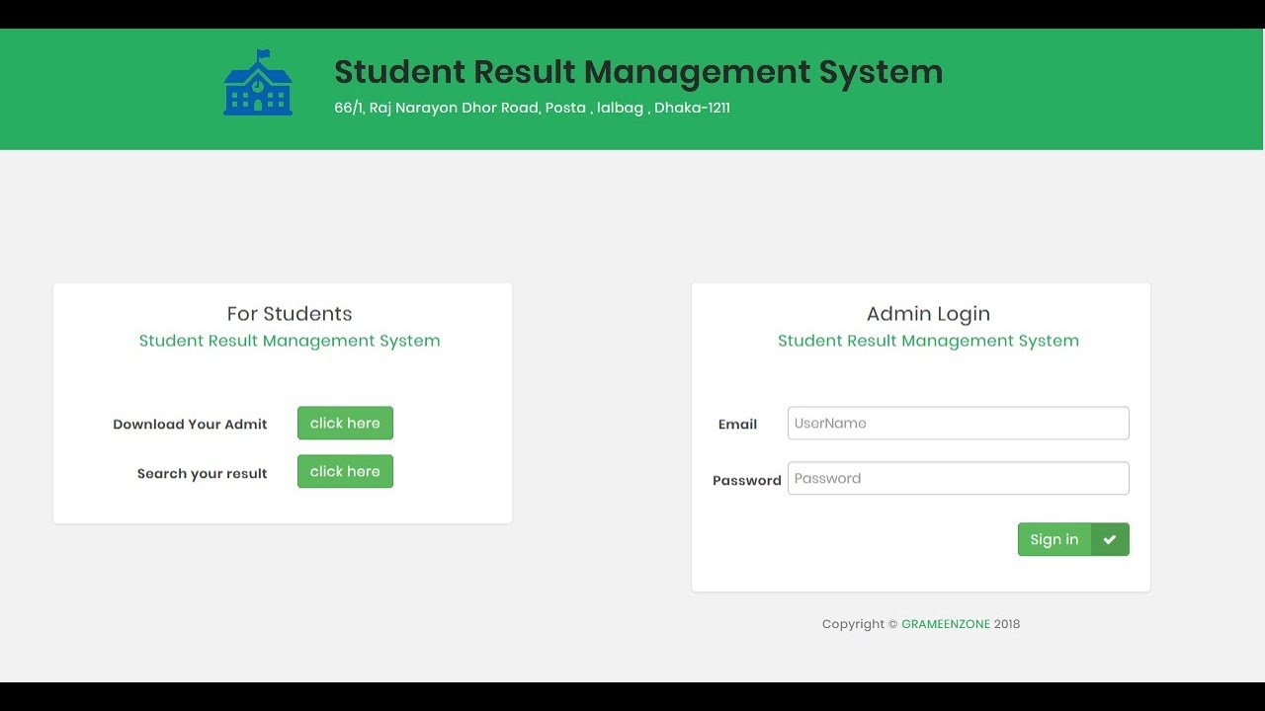

(Log in Page)

Page 8 of 12

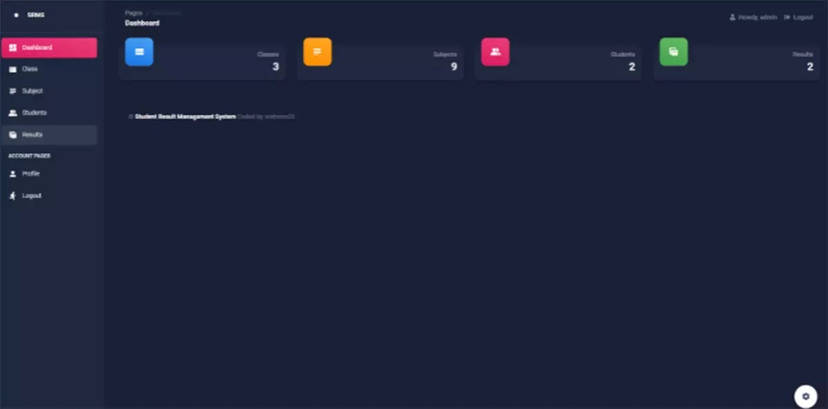

(Dashboard)

Page 9 of 12

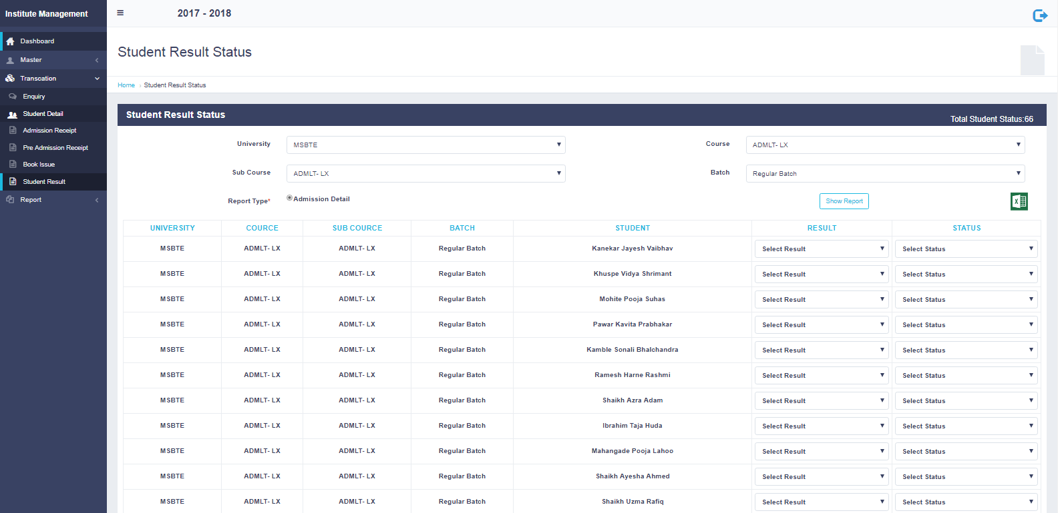

(Result Page)

Page 10 of 12

## Future Scope

It may help collecting perfect management in details. In a very short time, the collection will be obvious, simple and sensible. It will help a person to know the management of passed year perfectly and vividly. It also helps in current all works relative to Result Management System. It will be also reduced the cost of collecting the management & collection procedure will go on smoothly.

Our project aims at Business process automation, i.e. we have tried to computerize various processes of Result Management System.

* + In computer system the person has to fill the various forms & number of copies of the forms can be easily generated at a time.
  + In computer system, it is not necessary to create the manifest but we can directly print it, which saves our time.
  + To assist the staff in capturing the effort spent on their respective working areas.
  + To utilize resources in an efficient manner by increasing their productivity through automation.
  + The system generates types of information that can be used for various purposes.
  + Be easy to understand by the user and operator
  + Delivered on schedule within the budget.

Page 11 of 12

## Reference

✔ **Book References:**

* JavaScript: The Complete Reference Powell, Thomas A. By Schneider
* Fundamentals Of Database System By Durvasula V.L.N. Somayajulu
* **Online References:**
  + [www.w3schools.com](http://www.w3schools.com/)
  + [www.betalabs/youtube.com](http://www.betalabs/youtube.com)
  + [www.mdn.com](http://www.mdn.com/)
  + [https://github.com](https://github.com/) • [https://stackoverflow.com](https://stackoverflow.com/)
* **Faculty Guidelines:**

**Mr. Manoj Varshney**

**(Assistant Professor, GLA University)**

**Mr. Mandeep Singh**

**(Assistant Professor, GLA University)**

Page 12 of 12